Work Sheet 3

NAME: MOHAMED MIGDHADH

STUDENT ID: S2200065 (VILLA COLLEGE) | 22023480 (UWE)

MODULE CODE: UFCEVK-15-2

MODULE TITLE: INTERNET OF THINGS

**Introduction:**

The task of this work sheet was to develop a program that represents the internet of things. We were given the opportunity to develop what we wanted without any restrictions other then the set desirables stated above. For this challenge I decided to develop a simple alarm system with 3 components in mind, a sensor, an alarm and a remote. These will be all microBit devices. The program is written separately and will be connected to each other by a radio group. The sensor will listen for loud sounds and if hear, the alarm will play display an intruder alert and then start playing the alarm sound and then a remote is used to turn of the alarm.

**Design steps:**

* For all the programs the necessary all the necessary modules as shown below.

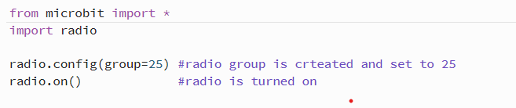

* For the sensor program “if microphone.current_event() == SoundEvent.LOUD:” is used to listen for loud sounds.
* If a loud sound is heard “radio.send("1")” is used to broadcast the string 1 to the other devices.

* For the alarm program an intruder variable is set initially to 0.
* “incoming = radio.receive()” is used to grab incoming messages.
* If the incoming message is a string 1, “microbit.display.scroll("INTRUDER ALERT", delay=50)” displays the intruder alert on the alarm display.

* After which “Intruder = 1” is used to set the intruder variable to 1.

* By using “while Intruder == 1:” and “music.play(['I6','J:3'])” the alarm sound is played in a loop.
* In the remote program “if button_a.was_pressed():” and “radio.send("0")” is sued to broadcast string 0 to the other devices.
* In the alarm program “incoming = radio.receive()” is used inside the “while Intruder == 1:” while loop to grab other incoming messages.
* If incoming message is a string 0, “microbit.display.scroll("INTRUDER CAPTURED", delay=50)” displays intruder captured message on the alarm display and sets the intruder variable back to 0.
* Since the “while Intruder == 1:” condition is false now “break” is used to go out of the while loop.

**Inputs and their corresponding outputs:**

* Loud sound is heard, for example someone hitting the table. The sensor microbit picks upon the loud sound and then it broadcasts the message “1” to all the other devices in the group.

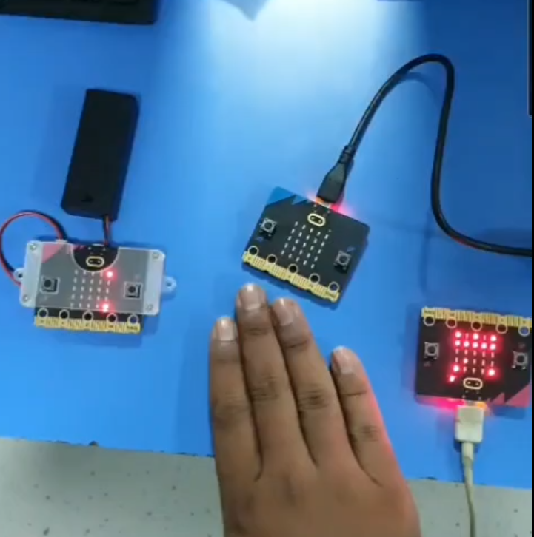

* The alarm receives the message “1”.
* The alarm displays the message “Intruder Alert” and starts playing the alarm sound.

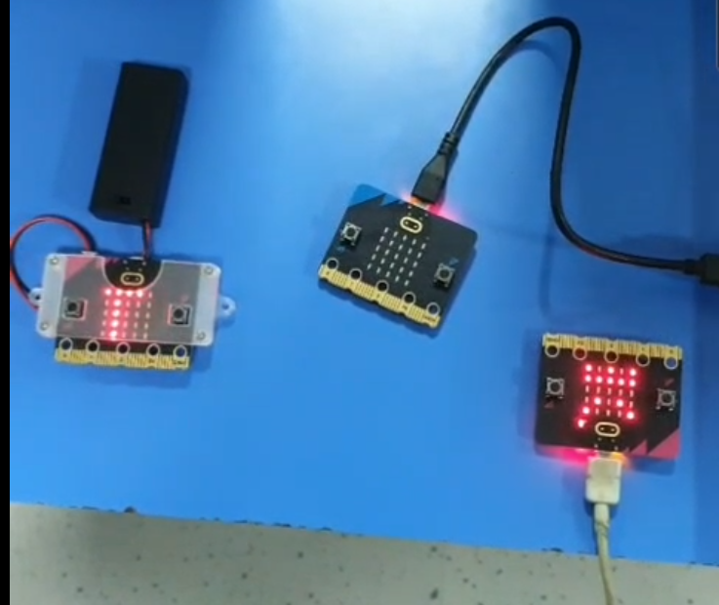

* Once the security breach is attended to, button A on the remote is pressed and it broadcasts the message “0” to the other devices in the group.

* The alarm receives the message “0”.
* The alarm displays the message “Intruder captured” and stops playing the alarm sound.

